Open Command Prompt & Go to Home Directory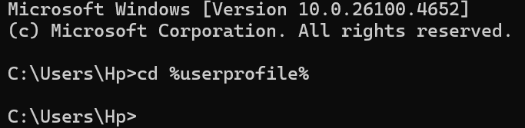

Create Required Folers
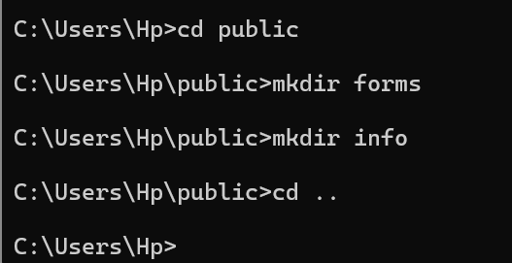

Move leave.txt to Archive & Rename
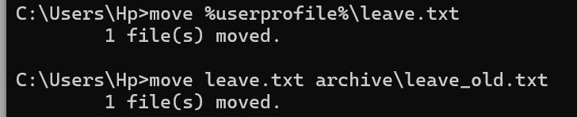

Move leave_old.txt to Forms Folder

Copy Customer File to Archive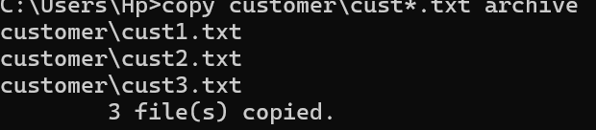

Move cust1,cust2,cust3 to Customer Folder
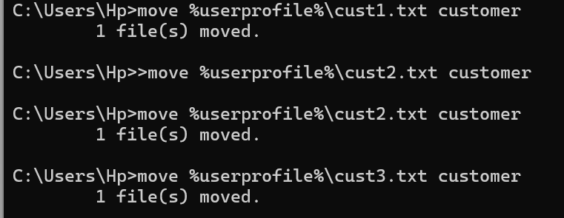

Final Directory Check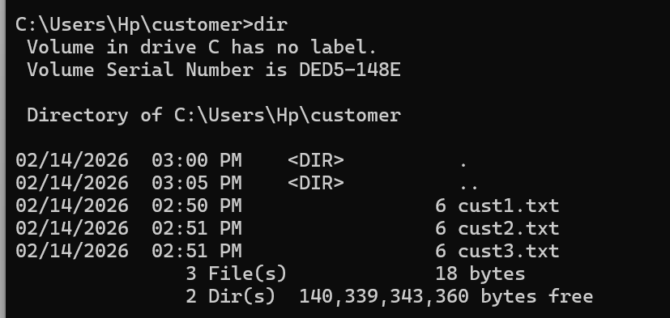

THE END

